Trade-offs in Textual Data Extraction Methodologies:
A Case Study of Army Career Progression Document Data
Nakshatra Yalagach and Sara Shallenberger
Abstract and general, Passive, Tense, Mood, ambiguous pronoun, nonstandard English
Introduction
For the data scientist, coercing information from an unstructured text format to configuration for analysis can be daunting. For this reason, computer and data scientists developed many solutions to this problem, each of which requires different considerations. We had the opportunity to explore these methods as interns for the University of Virginia’s Biocomplexity Institute for Social and Decision Analytics Decision on a project sponsored by the Army Research Institute for the Behavioral and Social Sciences.
Our goal for the first phase of the project was to explore methodologies for extracting data from PDF files and begin exploratory analysis on this textual information. We plan to use the resulting data in the following stages of our project, which analyzes the career progression of soldiers across Army branches. As a by-product of our project, we will contribute information pertaining to Large Language Models (LLMs) to open source-repositories.
Data
The textual data in the first phase project was sourced from officer development manuals for 14 Army operations and information dominance branches. These manuals detail the theoretical or ideal career pathway milestones for Army officers. We targeted three main data attributes in our extraction:
- Rank (Lieutenant, Captain, etc.)
- Assignment (an officer’s position or job)
- Type of Assignment
  - Key Developmental or Broadening
  - Key Developmental assignments are critical for officer promotion and overall career advancement compared to Broadening assignments
This text data was particularly challenging to work with because each document was written with its own unique headers, formatting, bulleting, and language describing assignments and their types.
Challenges
One of the major challenges with the text extraction from the officer development manuals was the inconsistent documentation. The structure, format, and data were inconsistent. As depicted in the below figures data is present in different structures across documents.
Fig 1: Sample Document A – Air Defense Artillery

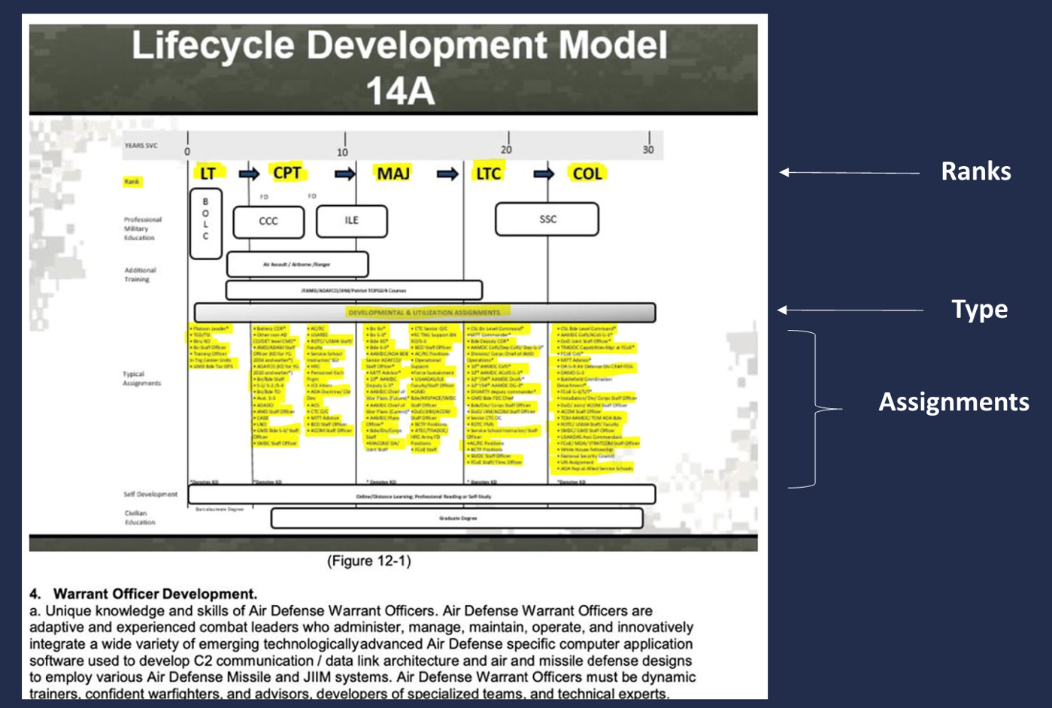
Fig 2: Sample Document A – Air Defense Artillery

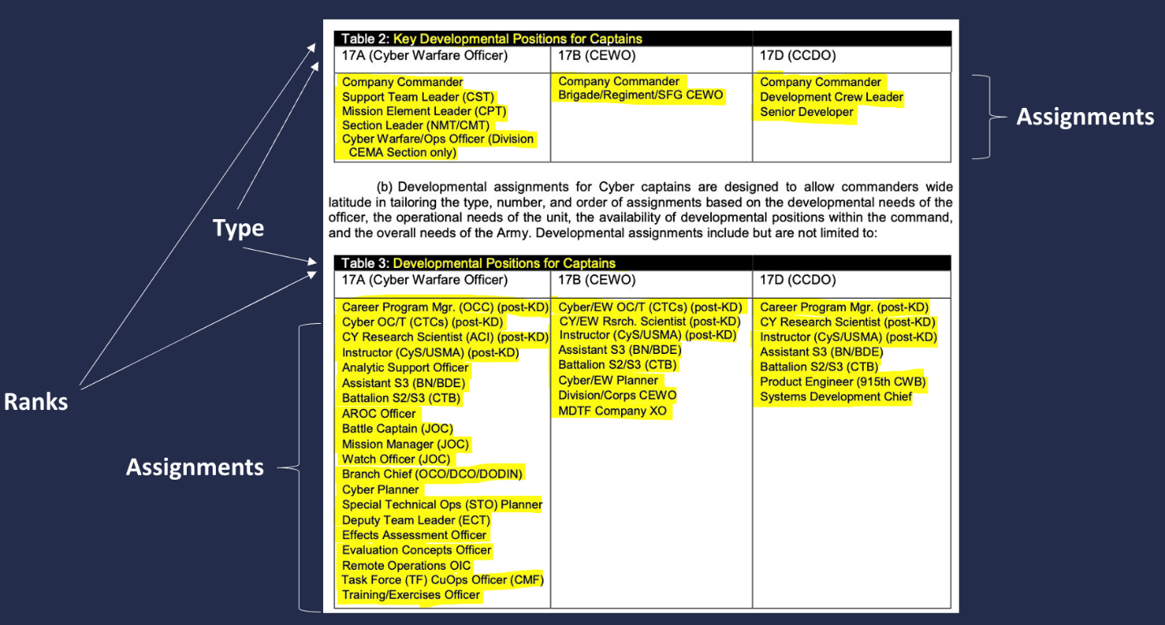Fig 3: Sample Document B: Cyber Branch

Figure 1 presents a snapshot of the Air Artillery Document, displaying the assignments arranged in alphabetical order. Additionally, Figure 2 illustrates the assignment information within the same document in image format. In the case of the Cyber Branch document, the data is presented in a tabular format, as depicted in Figure 3. Due to these inconsistencies, it is necessary to explore various methods to identify a robust approach that consistently yields accurate results across all documents.
Methods
Throughout the duration of this project, we have thoroughly examined a range of text extraction techniques. Moreover, we have provided comprehensive assessments of the advantages and disadvantages associated with each technique. By documenting these findings, we aim to facilitate future studies, enabling them to leverage the knowledge gained from our research. The advantages and disadvantages of each method can be assessed with the requirements of the project to enable the selection of the most suitable approach.
Method 1 – Image Upscaler
Since the document contained an image encompassing ranks, assignments, and their types, we deemed it advantageous to extract the data from the image. However, the image itself was of notably low quality. Consequently, our initial approach involved upscaling the image to enhance its resolution. We experimented with various combinations, including 200x and 400x upscaling. While these methods did improve the image quality to some extent, the extracted assignments remained difficult to read and comprehend. Therefore, we transitioned to employing text extraction techniques using ChatGPT to overcome this challenge.
Advantages:
Image upscaling offers several advantages, including improved resolution, reduced noise, and time efficiency. By enhancing the resolution of images, upscaling techniques contribute to a clearer and more detailed visual representation. Additionally, the reduction of noise artifacts in the upscaled images enhances their overall quality, while the time efficiency of the upscaling process allows for faster and more streamlined image enhancement workflows.
Disadvantages:
Image upscaling techniques can present drawbacks including the potential for distorted results, illegible output, and only partial improvement in image quality. These limitations can arise due to the inherent challenges in extrapolating information to a higher resolution. Furthermore, while some improvement in quality can be achieved, the upscaling process may not fully address all the nuances and details of the original image.
Method 2 - ChatGPT
The methodology employed for text extraction using ChatGPT involved providing a prompt along with the relevant section of the document containing the assignments. Multiple prompts were tested and experimented with, ultimately selecting the prompt that yielded the most accurate results. However, a challenge arose as slight rearrangements of the words in the prompt led to different outputs from GPT. Furthermore, another obstacle emerged when attempting to extract data for "Lieutenant Colonel" and "Colonel" assignments, as GPT failed to retrieve the desired information. Due to these limitations and inaccuracies in the results, the decision was made to transition to a Regex-based approach.
Advantages:
It offers several advantages, including its ease and speed of implementation, the ability to reuse prompts for consistent results, and its effectiveness in extracting data across various test documents. This makes ChatGPT a convenient and efficient tool for text extraction tasks, ensuring consistent and reliable outcomes regardless of the document being analyzed.
Disadvantages:
It does have certain limitations, such as being sensitive to user input, potentially generating varying outputs for identical prompts, and exhibiting less precision in extracting assignments. These drawbacks highlight the need for careful and specific input formulation to achieve desired results, while acknowledging the inherent challenges of maintaining consistency and precision in the extraction process.
Method 3 - Regular Expressions
The final method we explored to extract data from the Army documents was the use of regular expressions, which match strings of interest in the text. Unlike the ChatGPT method, writing regular expressions took more time on the part of the scientist. Since each branch used a unique formatting style, our regular expressions had to be modified for each document. A basic function using regular expressions would iterate through each character in the document and match to the sections following bullet points.
While this highly supervised extraction method was more time-intensive, it also allowed for the most precise extraction of assignments of the three methods explored and allowed for better control of the output format.

Chosen Method
We chose the regular expression technique as the final method to extract data from documents. This method was the best fit for our set of data because we had a small number of documents (14), and favored reproducible results that captured the most individual assignments and their types over the more variable outputs produced by ChatGPT. We noted that if our dataset was much larger, this method would not be ideal because of how time intensive it was to make edits to the code for each document we needed to analyze. However, this method was satisfactory for completing our goals during this phase of the project.
Conclusion
The data extraction phase of the Army Research Institute project demonstrated that there is no ideal way to extract data from documents. At the end of the day, it comes down to you, the scientist, to choose a solution that best fits your data, timeframe, reproducibility, and analysis goals.

